`
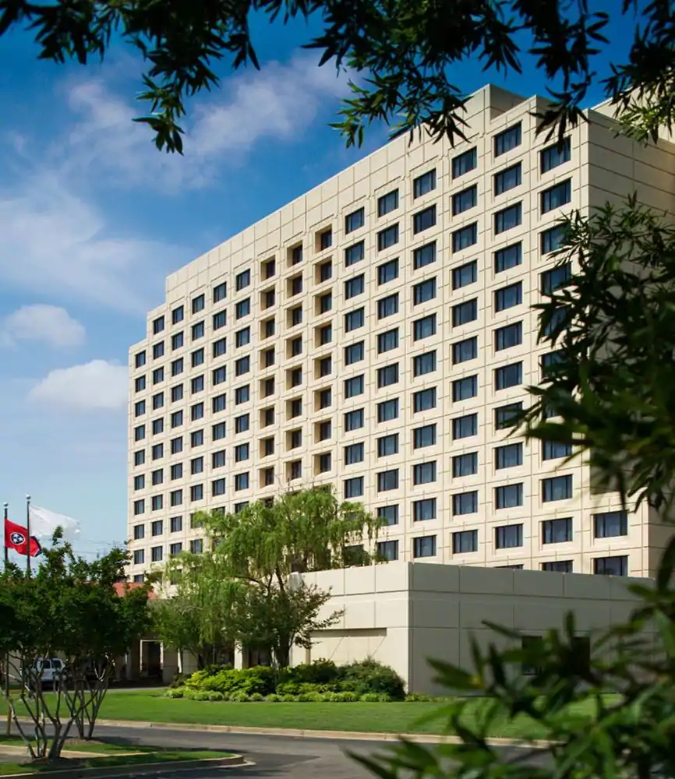
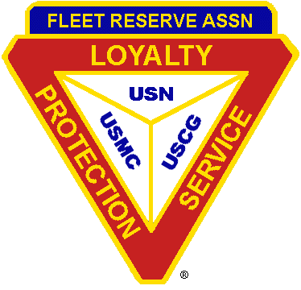

Newsletter # 3
Greeting Shipmates and Auxiliary Members
Memphis, Tennessee has been selected as the site for the 2019 National Convention by the National Committee. The hotel selected is the Crowne Plaza Memphis East at 2625 Thousand Oaks Blvd., Memphis, TN 38118. The dates are from September 22 – 29, 2019. It is located I-240 and Perkins 8 miles from the Memphis International Airport and 16 minutes from downtown & 13 minutes from Graceland.
There is on-site self-parking which is complimentary. Complimentary airport transportation to and from the hotel and within a five-mile radius of the hotel.
Room Rates are $99.00 (without Breakfast) plus 17.75% tax and the City of Memphis Hotel Tourism Fee of $2.00 per day or $109.00 (which includes a Full and Complete Breakfast). Room rates apply for up to three days prior and three days following the convention dates. The cut-off date for the block of rooms will be held until Sunday, September 1, 2019. Reservation requests received after 5:00 PM local time at the hotel on the cut-off date will be accepted based on guest room availability at the Group rate.
Telephone Number: Crowne Plaza Worldwide Reservations 844-750-1135

Hyper Link: These links below will take right to the hotel sight and you will see once you pick your room type (double or queen), Fleet Reserve Association appears on the reservation as you reserve the room with a credit card.

Fleet Reserve WITHOUT Breakfast

Fleet Reserve WITH Breakfast

Block codes are: FLA (doesn’t include breakfast $99.00) and FLB (includes breakfast $109.00).
Reservations can be made by calling Crowne Plaza Worldwide Reservation at 844-750-1135 be sure to mention “Fleet Reserve Association”.
The 2019 National Convention is being hosted by the Fleet Reserve Association (FRA) and being handled by the National Committee which was elected by the delegates. All profits/losses will be borne by the Fleet Reserve Association and the Ladies Auxiliary of the Fleet Reserve Association. So, it is imperative that the shipmate and auxiliary members make reservations and support this convention.
Tuxedo Rental: Gents Formal Wear located at 11125 Hwy 70, Arlington, TN. - Phone (901) 867-1977. Cost $119.00. Tuesday fitting, September 24, 2019 and will be delivered on Friday, September 27, 2019 and Pick Up Tuxes on Sunday September 29, 2019.

Electric Scooters Rental. Two Locations – Renters choice
1. Memphis Home Medical Equipment, 9087 Popar Avenue, German, TN – Phone (901) 759-1919. Weekly Rental - $100.00 for the week. Delivery and Pick-Up Charge $100.00.
2. Electric Scooter Rental (Memphis), Mid-South Medical & Mobility, Medical Supply Memphis, TN., 5140 Old Summer Road, Memphis, TN – Phone (901) 683-3543. Weekly Rental $165 for the week. Delivery and Pick-Up Charge $50.00.

Welcome Aboard Party. The “Welcome Aboard Party” will be held on Wednesday, September 25, 2019 at 1830 in the Thousand Oaks Ballroom. The theme of the event will be “Elvis is in the House”. Members of the Entertainment Committee is putting together a show that promises to amuse and entertain you. However, we need your help to ensure that you will have a pleasant and entertaining evening. Admission to the “Welcome Aboard Party” will be $10.00 per person.

Banquet and Grand Ball. Banquet and Grand Ball Banquet will be held on Saturday, September 28, 2019 at 1930 in the Grand Ballroom ABCDEFGH.

Tours.
Monday - 9/23/2019 - 1200 – 1700 (Includes Transportation and Entrance Fee)
Graceland “Elvis Experience Tour” The Mansion tour, plus exhibits showcasing Elvis’s career, his automobiles, his wardrobe, his gold records and much more from the Graceland Archives includes: Graceland Mansion Audio-Guided with new orientation film Tour; Access to Elvis Presley’s Memphis, including: Presley Motors Automobile Museum; Elvis: The Entertainer Career Museum; Elvis Discovery Exhibits.
Tuesday – 9/24/2019 – 0900 – 1230 (Transportation Only)
Guided Tour of Memphis: Lively 90 minute drive features live music and the very best of Memphis – Beale Street, Sun Studio, Overton Park, Peabody Hotel, Stax Studio, Lorraine Motel, Movie and TV Locations, Elvis, BB King and Johnny Cash homes, plus a guided tour of Sun Studio, where Elvis Presley, Jerry Lee Lewis, and Johnny Cash launched their Careers.
Thursday – 9/26/2019 – 1600 – 2200 (Includes Transportation and Ticket to Game)
Navy vs University of Memphis: Collage Football Game between the Midshipman of Annapolis, MD (NAVY) and the Tigers of the University of Memphis at Tiger Stadium in Memphis.
Friday – 9/27/2019 – 1700 – 2300 (Transportation Only)
Casino trips to Tunic in Mississippi or West Memphis in Arkansas.
2019 Convention Meals

Tuesday 9-24-2019
FRA PRP Board of Directors Breakfast (Closed)
The Southern Buffet
Seasonal; Fresh Fruit Display; Fluffy Scrambled Eggs; Smoked Bacon & Sausage Links; Muffins, Danishes & Pastries; Buttermilk Biscuits & Gravy; Breakfast Potatoes; Assorted Fruit Preserves & Butter; Assorted Chilled Juices; Regular & Decaf Coffee; Hot Tea.
Past National Chaplains Breakfast (Closed)
C A N C E L L E D
Wednesday 9-25-2019
FRA Past National Presidents Lunch (Closed)
BBQ Beef Brisket
Slow-smoked Beef layered on Sourdough Bread with Boursin Cheese & Zebo’s Slaw; Served with Chips & a Gourmet Cookie; Bottled Water or Soda.
LA FRA Past National Presidents Lunch (Closed)
Call Rockin’ Grilled Ham & Cheese
Four-Cheese Blend, Honey-Smoked Ham, Sliced Avocado, Grilled Onions & Cranberry Jam served on a Flaky Croissant; Served with Chips & a Gourmet Cookie; Bottled Water or Soda.
FRA RP/RPE/RVP Lunch (Closed)
and
LAFRA RP/RPE/RVP Lunch (Closed)
All Day Club Wrap
Fried Chicken Breast, Honey Ham, Smokey Bacon, Swiss Cheese and Tomatoes wrapped in a whole Wheat Tortilla; Served with Chips and a Gourmet Cookie; Bottle Water or Soda.
Welcome Aboard (Open)
Finger Food - Snacks
Thursday 9-26-2019
FRA PRP Breakfast (Closed)
The Crowne (Buffet)
Seasonal Fresh Fruit Display; Fluffy Scrambled Eggs; Smoked Bacon & Sausage Links; French Toast; Belgian Waffles; Warm Maple Syrup Whipped Cream & Strawberry Topping; Assorted Fruit Preserves & Butter; Assorted Chilled Juices; Regular & Decaf Coffee & Tea.
LA FRA PRP Lunch (Closed)
The “Tom”
Smoked Turkey Breast on a multi Grain Roll with Swiss Cheese, Crispy Bacon, Lettuce, Tomato, & Mayonnaise; Served with Individual Bag Chips & a Gourmet Cookie; Bottled Water or Soda.
Friday 9-27-2019
NP Luncheon (Open)
Chicken Marsala
Field Greens with Tomatoes, Cucumbers, Feta Cheese & Assorted Dressing; Seared Chicken Breast with Marsala Mushroom Sauce; Served with Sautéed Garden Vegetables & Roasted Garlic Mashed Potatoes; Ultimate Chocolate Cake; Iced Tea and Water.
Saturday 9-28-2019
Banquet (Open)
Salad – Hearts of Romaine with Garlic Croutons & Parmesan Caesar Dressing.
Main Course Choice:
Pesto Marinated Chicken
Panko Parmesan Crusted Chicken with Tomato Herb Reduction; Served with Creamy Scalloped Potatoes & Blue Lake Green Beans.
OR
Roasted Sirloin of Beef
Top Sirloin Steak with Horseradish Cream; Served with loaded Mashed Potatoes & Asparagus or Brussel Sprouts with a Balsamic Reduction
Dessert – French Silk Pie.
***********************************************************************************
Wellness Menu available: Those individuals having special dietary restrictions there are special meals being Gluten Free or Lactose Free, or Vegetarian available. Please indicate on the reservation form when submitted with payment your special needs.
***********************************************************************************
92nd FRA/87th LA FRA NATIONAL CONVENTION
SEPTEMBER 22 – 29, 2019 – MEMPHIS, TENNEESSEE

*ALL MEAL CHOICE ARE DUE BY 8/30/2019
MEALS RESERVATION FORM (1 of 2)
EVENT
DAY DATE TIME MENU COUNT PRICE TOTAL
************************************************************************************************************
FRA PRP Board of Director Breakfast (Closed)
Tues 09/24/19 0700 Buffet _____ x $ TBD = _____________
**************************************************************************************************
Combined FRA & LA FRA PNC Breakfast (Open to FRA & LA FRA PNC & Families) CANCELLED
**************************************************************************************************
FRA PNP Luncheon (Closed)
Wed 09/25/19 1115 BBQ Beef Brisket _____ x $32.00 = _____________
**************************************************************************************************
LA FRA PNP Luncheon (Closed)
Wed 09/25/19 1115 Call Rockin’ Grilled Ham & Cheese_____ x $32.00 = _____________
**************************************************************************************************
FRA RP, RPE, RVP Luncheon (Closed)
Wed 09/25/19 1115 All Day Club Wrap_____ x $32.00 = ______________
**************************************************************************************************
LA FRA RP, RPE, RVP Luncheon (Closed)
Wed 09/25/19 1115 All Day Club Wrap_____ x $32.00 = ______________
**************************************************************************************************
WELCOME ABOARD PARTY (Open)
Wed 09/25/19 1830 Finger Food & Snacks _____x $10.00 = ______________
**************************************************************************************************
FRA PRP Breakfast (Closed)
Thurs 09/26/19 0700 The Crowne (Buffet)______ x $35.00 = ______________
**************************************************************************************************
LA FRA PRP Luncheon (Closed)
Thurs 09/26/19 1115 The “Tom” ______ x $32.00 = ______________
**************************************************************************************************
LA FRA NP Luncheon (Open)
Fri 09/27/19 1130 Chicken Marsala _____ x $36.00 = _____________
**************************************************************************************************
BANQUET (Open)
Sat 09/28/19 1930 Pesto Marinated Chicken ______ x $50.00 = _____________

Roasted Sirloin of Beef______ x $50.00 = _____________
**************************************************************************************************
Vendor Table (6-Foot Table - $25) due by 9/8/19 with payment
No. of Days ______ x _____ $25.00 = ______________
**************************************************************************************************
Information Table (6-foot Table - No Charge) due by 9/8/19
No. of Days _____ $00.00 = ______________
**************************************************************************************************
Tours.
Mon 9/23/19 1200 – 1700 Graceland “Elvis Experience Tour” ______ x $100.00 =_____________
**************************************************************************************************
Tues 9/24/19 0900 – 1230 Guided Tour of Memphis _______x $30.00 = _____________
**************************************************************************************************
Thursday 9/26/19 1600 – 2200 Navy vs University of Memphis _______x $50.00 = _____________
**************************************************************************************************
Friday 9/27/19 1700 – 2300 Casino Trip _______x TBD_________
**************************************************************************************************
2nd FRA/87th LA FRA NATIONAL CONVENTION
SEPTEMBER 22 – 29, 2019 – MEMPHIS TENNESSEE.

PLEASE MAKE CHECKS PAYABLE TO:

2019 FRA National Convention

and mail to: 2019 National Convention P.O. Box 107, Rescue, CA 95672-0107

Individuals desiring to pay with a Credit Card please provide:

Name on Card _____________________________________________________CVV ____________

Card Number ________________________________________ Expiration Date ________________

***************************************************************************************

Name: ______________________________________ Branch/Unit #: _________

Address: ____________________________________

____________________________________

Phone: _______________________ Email: ______________________________

Total Amount Enclosed: $_______________

Due No Later Than August 30, 2019

All cancellation and reimbursements for meals will be considered on a one on one basis and must be submitted prior to the closing of the convention. This policy will be strictly adhered to due to the hotel requiring that the number of meals turned in be paid for prior to the commencement of the convention

2019 NATIONAL CONVENTION
MEMPHIS, TENNESSEE
CONVENTION JOURNAL ADS SOLICITATION

Name of Advertiser: _________________________________ Branch/ Unit: __________
Address:________________________________________________________________________________________________________________________________________________________________________________________________________________
Phone: __________________ Email: _________________________________________
_____ Inside Cover (Front or Back) $200.00 _____ Back Cover $250.00
_____ Full Page $150.00 _____ Half Page $75.00
_____ ¼ Page $40.00 _____ 1/8 Page (Business Card) $25.00
_____ Center Spread (In Color) $500.00
Booster Rolls ($1.00 per name donation preferred)
= = = = = = = = = = = = = = = = = = = = = = = = = = = = = = = = = = = = = = = = = = = = = = = = = =
"Artwork and booster lists can be emailed to prpnwlazz@fra-nwregion.org. Acceptable formats are .doc, .pub, .png, and .jpg."
PLEASE MAKE CHECKS PAYABLE TO:
2019 National Convention
And mail to:
2019 National Convention Committee
PO Box 107, Rescue, CA 95672-0107
Deadline for Ad to be published is 30 August 2019

CONVENTION TENTATIVE SCHEDULE
“Disclaimer: Schedule is subject to change.”

DATE TIME ACTIVITY/EVENT ROOM
Monday 1200 – 1700 Tour – Graceland Tentative
9/23/2019 1200 – 0000 Hospitality Room 14th Floor Lounge
**** 0800 – 1700 All Week – Budget/Finance Committee Governors Boardroom
**** 0800 – 1700 All Week – FRA Office Poplar 2
**** 0800 – 1700 All Week – LAFRA Office Executive Boardroom

Tuesday 0700 - 0900 PRP Beal Breakfast Perkins 1
9/24/2019 0700 – 0900 PNC Breakfast CANCELLED
0900 – 1230 Tour – Downtown Memphis Tentative
0900 – 1200 FRA Registration Foyer Area
0900 – 1200 LA FRA Registration Foyer Area
1300 – 1500 FRA Pre Board Meeting Grand Ballroom Salon ABCD
1300 – 1500 LA FRA Pre Board Meeting Grand Ballroom Salon EFGH
1500 – 1700 Workshop Poplar 1
1500 – 1700 FRA Registration Foyer Area
1500 – 1700 LA FRA Registration Foyer Area
1500 – 2300 Hospitality Room 14th Floor Lounge
1600 – 1700 FRA Education Foundation Meeting Governors Boardroom

Wednesday 0730 – 0830 FRA Registration Foyer Area
9/25/2019 0730 – 0830 LA FRA Registration Foyer Area
0730 – 0830 Workshop Popular 1
0900 – 1100 Opening Ceremony Grand Ballroom ABCDEFGH
1115 – 1245 FRA PNP Luncheon Perkins 1
1115 – 1245 LA FRA PNP Luncheon Perkins 2
1115 – 1245 FRA RP, RPE, RVP Luncheon Thousand Oaks Ballroom (Lower)
1115 – 1245 LA FRA RP, RPE, RVP Luncheon Thousand Oaks Ballroom (Upper)
1130 – 1245 Workshop Poplar 1
1130 – 1300 FRA Registration Foyer Area
1130 - 1300 LA FRA Registration Foyer Area
1300 1700 FRA 1st Business Session Grand Ballroom Salon ABCD
1300 – 1700 LA FRA 1st Business Session Grand Ballroom Salon FGH
1700 – 1930 Hospitality Room 14th Floor Lounge
1700 – 1830 Workshop Perkins 1 & 2
1830 – 1100 Welcome Aboard Reception Thousand Oaks Ballroom

Thursday 0700 – 0800 FRA Registration Foyer Area
9/26/2019 0700 – 0800 LA FRA Registration Foyer Area
0700 – 0815 FRA PRP Breakfast Thousand Oaks Ballroom
0800 – 1100 LA FRA 2nd Business Session Grand Ballroom Salon FGH
0815 – 0900 FRA Legislative Service Perkins 1 & 2
CONVENTION TENTATIVE SCHEDULE
“Disclaimer: Schedule is subject to change.”

DATE TIME ACTIVITY/EVENT ROOM
Thursday 0900 – 1100 Budget & Finance Governors Boardroom
9/26/2019 0900 – 1100 FRA C & BL Grand Ballroom Salon E
0900 – 1100 FRA Veterans Service Poplar 1
0900 – 1100 FRA Americanism Patriotism Grand Ballroom Salon A
0900 – 1100 FRA Youth Activities Grand Ballroom Salon D
0900 – 1100 FRA Honorary Membership Thousand Oaks Ballroom (Lower)
0900 – 1100 FRA Public Relations Grand Ballroom Salon C
0900 – 1100 FRA Hospital & Welfare Grand Ballroom Salon B
0900 – 1100 FRA Time & Place Thousand Oaks Ballroom (Lower)
0900 – 1100 FRA Future Planning Thousand Oaks Ballroom (Upper)
0900 – 1100 FRA Membership Perkins 1 & 2
1115 – 1230 LA FRA PRP Luncheon Thousand Oaks Ballroom
1130 – 1245 Workshop Perkins 1 & 2
1300 – 1600 FRA 2nd Business Session Grand Ballroom ABCD
1300 – 1600 LA FRA Committee Meetings Grand Ballroom FGH
1600 – 2300 Hospitality Room 14th Floor Lounge
1600 – 2200 Navy vs Univ of Memphis Tentative
1630 - 1830 Workshop Perkins 1 & 2

Friday 0700 – 0800 FRA Registration Foyer Area
9/27/2019 0700 – 0800 LA FRA Registration Foyer Area
0730 – 0830 Workshop Perkins 1 & 2
0900 – 1100 FRA 3rd Business Session Grand Ballroom ABCD
0900 – 1100 LA FRA 3rd Business Session Grand Ballroom FGH
1130 – 1230 FRA Registration Foyer Area
1130 – 1230 LA FRA Registration Foyer Area
1130 – 1245 LAFRA NP Luncheon Thousand Oaks Ballroom
1130 – 1245 Workshop Perkins 1 & 2
1300 – 1600 FRA 4th Business Session Grand Ballroom ABCD
1300 – 1600 LA FRA 4th Business Session Grand Ballroom FGH
1600 – 2300 Hospitality Room 14th Floor Lounge
1630 – 1830 Workshop Perkins 1 & 2
1700 – 2300 Bus Trip to Casino Tentative

Saturday 1000 – 1200 Installation Rehearsal Thousand Oaks Ballroom
9/28/2019 1600 – 1800 Photos Perkins 1 & 2/Atrium Courtyard
1800 – 1900 Installation of Officers Thousand Oaks Ballroom
1915 – 1930 Cocktails Foyer Area
1930 - 2300 Banquet & Dance Grand Ballroom ABCDEFGH

CONVENTION TENTATIVE SCHEDULE
“Disclaimer: Schedule is subject to change.”

DATE TIME ACTIVITY/EVENT ROOM
Sunday 0830 – 1000 FRA Post Board Meeting Grand Ballroom ABCD
9/29/2019 0830 – 1000 LA FRA Post Board Meeting Grand Ballroom EFGH

2019 National Convention Committee
Chairman (FRA) Lawrence “Larry” Boudreaux, PNP (530) 677-3925 larryboo@pacbell.net
Co-Chairman (FRA) Virgil P. Courneya, PNP (775) 882-9201 virgil_courneya@att.net
Chairman (LA FRA) Helen Courneya, PNP (775) 882-9201 vpc-hac-patches@att.net
Co-Chairman (LA FRA) Pat Boudreaux, PNP (530) 677-3925 larryboo@pacbell.net
Treasurer Michael “Mick” Fulton, PRPSW (619) 410-1660 mickfulton@adeptworks.net
Member Cindy Rodham-Tuck, PNP (508) 238-3607 cindyrodhamtuck@gmail.com
Member “John” Johnson, PNP (253) 770-5935 mwjohn4@comcast.net
Member Pete Lazzaretti PRPNW (253) 444-7516 prpnwlazz@fra-nwregion.org
Member Diane Hoover PNP (410) 757-9325 ladydihoover26@gmail.com

