December 8, 2011

The Honorable Howard P. McKeon
Chairman, Armed Services Cmte.
U.S. House of Representatives
2120 Rayburn Office Building
Washington, DC 20515

Fax: 202-228-0858

The Honorable Adam Smith
Ranking Member, Armed Services Cmte.
U.S. House of Representatives
2402 Rayburn Office Building
Washington, DC 20515

Fax: 202-225-5893

Dear Mr. Chairman and Ranking Member Smith:

The Fleet Reserve Association (FRA) fully supports the extensive Military Coalition (TMC) recommendations regarding the FY 2012 National Defense Authorization Act (NDAA) that’s being sent under separate cover. Our members also appreciate important personnel related provisions addressed in both the House and Senate versions of legislation including the 1.6 percent active duty pay increase effective January 1, 2012, limiting future TRICARE Prime fee adjustments to the annual Consumer Price Index which is the basis for annual retired pay COLA adjustments, the elimination of pharmacy co-pays for generic home delivery, and supplemental Impact Aid funding for schools with significant military populations. The Association welcomes the increase in the Navy Reserve end strength but remains concerned that Navy end strength reductions will force more deployment burdens – and associated stress on active duty personnel, the Reserve Component and their families.

The following issues are important to our membership and addressed in only one of the respective bills. FRA urges conferees to support the Senate provision (Section 635, Amdt 1209) that eliminates the SBP/DIC offset, the House provision (Section 902) that redesignates the Department of the Navy as the Department of the Navy and Marine Corps, the House provision (Section 603) to extend authority to provide lodging accommodations for Navy pre-commissioning unit enlisted personnel assigned to ships that are under construction or repairs, and strongly opposes deep cuts in funding for military music programs in the House bill (Section 599c) given the significant role of military bands in ceremonies, funerals, protocol events, community relations programs and the enhancement of troop morale.

Your consideration of these recommendations is appreciated. For additional information please contact John Davis, FRA’s Director of Legislative Programs at (703) 683 -1400.

Sincerely,
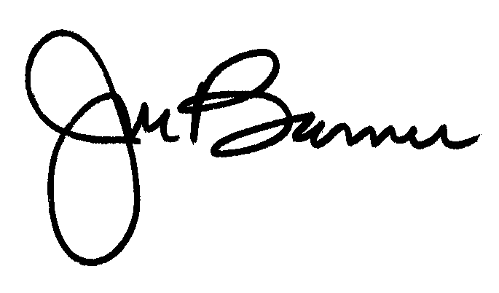
JOSEPH L. BARNES
National Executive Director
JLB:aal

cc: The Honorable Joe Wilson
The Honorable Susan Davis

