April 23, 2012

The Honorable John A. Boehner
Speaker
U.S. House of Representatives
H-232
Washington, DC 20515

Fax: 202-225-0704
The Honorable Harry Reid
Majority Leader
United States Senate
S-221
Washington, DC 20510

Fax: 202-224-7327

Dear Speaker Boehner and Majority Leader Reid:

Members of the Fleet Reserve Association (FRA) are very concerned about the effects of “sequestration” on the Department of Defense in 2013 and beyond as mandated by the Budget Control Act of 2011. The Association noted Secretary of Defense Leon Panetta’s recent comments that these cuts “would do catastrophic damage to our military, hollowing out the force and degrading its ability to protect the country.” It is significant that defense spending totals 17 percent of the federal budget, yet 50 percent of the sequestration cuts are targeted for DoD.

The Department has already identified more than $480 billion in budget cuts over the next 10 years and, unless Congress acts, provisions of the Budget Control Act mandate another $500 billion to $600 billion in cuts beginning in 2013. Cuts of this size endanger modernizing an aging fleet, lower personnel morale with the necessarily increased operational, and reduce incentives vital to the recruitment and retention of our highly trained men and women.

Your attention to authorizing alternatives to sequestration with regard to defense spending is of utmost importance to our membership – and to sustaining military readiness and our national security.

Sincerely,
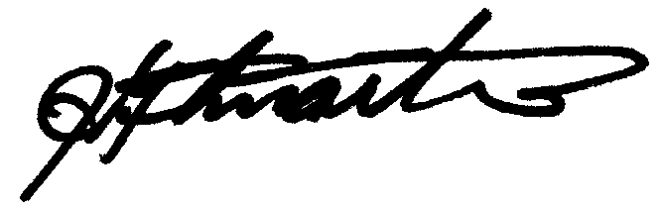
JEFFREY A. GILMARTIN
National President
JAG:aal

cc: The Hon. Nancy Pelosi
The Hon. Mitch McConnell
The Hon. Howard “Buck” McKeon
The Hon. Adam Smith
The Hon. Carl Levin
The Hon. John McCain

