March 12, 2013

The Honorable Duncan Hunter
U.S. House of Representatives
223 Canon Office Building
Washington, DC 20515

Fax: 202-225-0235

Dear Representative Hunter:

The Fleet Reserve Association (FRA) supports the your legislation (H.R. 833) that prohibits the Department of Defense (DoD) from rating the Distinguished Warfare Medal equal to or higher than the Purple Heart medal.

Combat valor recognition has profound and significant meaning within the military community and recognition of non-combat service should not supersede recognition of valor on the battlefield. A military award that recognizes commendable non-combat actions off the battlefield is certainly appropriate; however, those engaged in direct combat put their lives on the line, accepting extraordinary personal risk and this reality will be fully acknowledged upon enactment of your legislation.

Thank you for introducing this legislation and your strong leadership on this important issue. We’ve listed this legislation on our Internet Action Center to encourage FRA members to contact their Representatives to ask for their support. The Association also stands ready to provide further assistance in advancing this legislation.

The point of contact is John Davis, FRA’s Director of Legislative Programs, at the above numbers or (john@fra.org).

Sincerely,
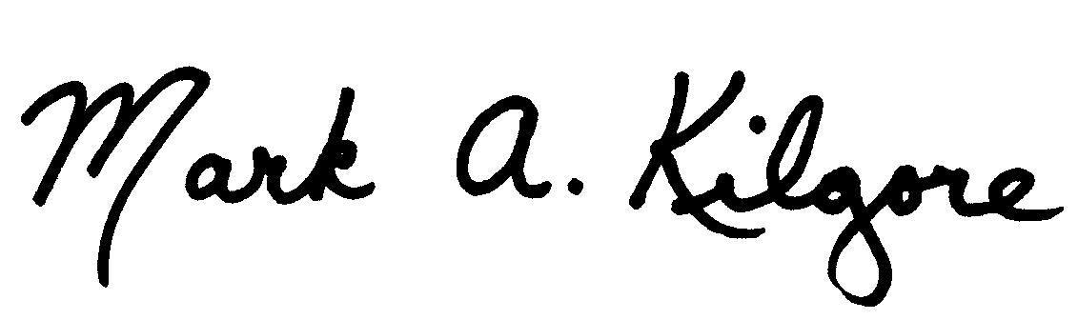
MARK A. KILGORE
National President

MAK:jrd:aal

