October 18, 2012

The Honorable Carl Levin
Chairman, Armed Services Cmte.
United States Senate
269 Russell Office Building
Washington, DC 20510

Fax: 202-228-0036
The Honorable John McCain
Ranking Member, Armed Services Cmte.
United States Senate
241 Russell Office Building
Washington, DC 20510

Fax: 202-228-2862

Dear Chairman Levin and Ranking Member McCain:

The Fleet Reserve Association (FRA) appreciates your efforts and those of the other members of the Armed Services Committees, and their respective staffs to protect benefits and programs for service members, military retirees, veterans, Reservists and their families in the FY 2013 National Defense Authorization Act (NDAA). With an abridged post-election Congressional schedule, FRA wanted to provide its recommendations before the Senate and conference committee deliberations on the NDAA. A number of provisions appear in both versions of the FY 2013 NDAA that FRA strongly supports, including increasing active duty pay by 1.7 percent, supplemental impact aid for schools with large military populations, and the one-year extension of active duty special pay, incentive pay and bonuses.

FRA fully supports the extensive Military Coalition (TMC) recommendations sent to you and other conferees and offers the following recommendations on key issues addressed only in one bill that are especially important to our membership.

Health Care Issues

FRA strongly supports provisions (sections 711 & 717-718) in the House bill that would provide reasonable pharmacy co-pay increases for FY 2013 and limit percentage increases beyond 2013 to the same percentage COLA increase for retired pay. These limitations after 2013 would ensure that increases in pharmacy co-pays would not erode retiree pay. The House bill also calls a five year program for TRICARE-for-Life (TFL) beneficiaries to use home delivery for maintenance drugs for at least one year. The Association also supports the section (711) that mandates a unified medical command that can provide substantial savings for the Military Health System (MHS) and the Sense of Congress (SOC) that acknowledges that TRICARE benefits have been earned with more than 20 years of arduous military service.

Pay and Retirement Commission

FRA strongly opposes the provision (Sections 1604-1614) in the Senate Committee approved bill that creates a BRAC-like commission on military pay and retirement benefits. This process would bypass the expertise of the Senate and House Armed Services Committees and only allow Congress an up-or-down vote on the commission’s recommendations. Although the changes will not adversely impact currently serving personnel and those who have retired, benefit changes directed at new service members could have unintended consequences on future recruitment and retention.

End Strength

FRA is concerned about reducing end strength to save money on the Defense budget while still engaged for more than 11 years in the War on Terror. The strain of repeated deployments continues and is directly related to adequate end strengths The Association supports the House passed provision (Section 403) that limits annual reductions for the Marine Corps for FY 2014-2017, however the Navy’s active and Reserve end strengths are to be reduced in 2013.

Predatory Lending Protections for Military

FRA strongly supports the provisions in the Senate bill (section 651-654) that strengthen the FRA-supported predatory lending protections for active duty personnel in the FY 2007 NDAA. The provisions in the pending Senate bill include the following:

- Eliminates certain definitional loopholes exploited by some lenders;
- Requires DoD to review the impact of installment loans aimed specifically at service members;
- Requires non-resident military to be protected by state credit laws; and
- Strengthens current law by providing service members private right of action with civil penalties.

Coast Guard Reserve

The Association strongly supports Section 663 of the House bill that mandates equal treatment for Coast Guard Reserves in terms of credit for early retirement and Post 9/11 GI Bill benefits.

Department of the Navy

FRA supports Section 905 of the House bill that will authorize changing the name of the Department of the Navy to the Department of the Navy and the Marine Corps.

Military Bands

FRA opposes Section 1099 B of the House bill that mandates arbitrary and sizeable cuts to military band funding. Military bands date back to the founding our Nation and military music is also essential to military recruiting efforts and ceremonies ranging from White House and DoD events, to funerals, special occasions, and major national observances.

Senate Floor Amendments

Sincee the Senate may not have adequate time to debate and vote on important amendments to the Senate bill. FRA strongly supports Majority Leader Reid’s (NV) efforts to offer a floor amendment to make substantial concurrent receipt improvements and supports Senator Bill Nelson’s (Fla.) amendment that would eliminate the SBP/DIC offset for surviving spouses of personnel who die of service-connected causes.

For additional information please contact John Davis, Director of Legislative Programs at (703) 683-1400 x-110.

Your consideration of these recommendations is appreciated.

Sincerely,
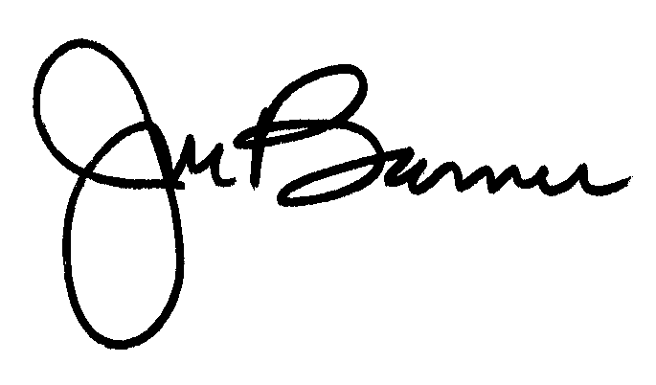
JOSEPH L. BARNES
National Executive Director
JLB:aal

cc: The Honorable James Webb (202) 228-6363
The Honorable Lindsey Graham (202) 224-3808

